Project Design Phase-II

Data Flow Diagram & User Stories
Date | 29 September 2026
Team ID | 6ab1d50c92b876d9664094bc
Project Name | Auto Ticket Classification Using Flow Designer
Maximum Marks | 4 Marks

Data Flow Diagrams
The DFD shows how a requester submits a ticket, how ServiceNow Flow Designer classifies it using predefined conditions, and how the ticket is routed to the appropriate support team. The diagrams below represent the proposed project design.

DFD Level 0 – Context Diagram
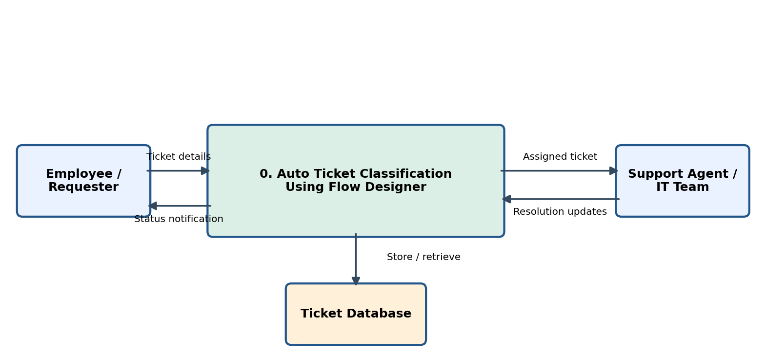
Input: ticket description, short description and requester details. Output: classified ticket, assignment and status notification.

DFD Level 1 – Detailed Process
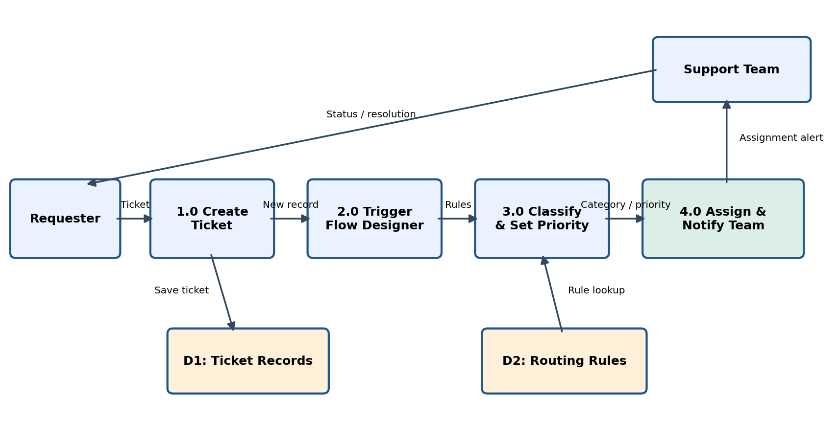

Process Description
1.0 Create Ticket: The requester submits a new incident with a short description and description.
2.0 Trigger Flow Designer: A record-created trigger starts the classification flow.
3.0 Classify & Set Priority: Decision conditions examine keywords or selected fields to set category, subcategory and priority according to configured rules.
4.0 Assign & Notify Team: The flow sets the assignment group and sends a notification. Unmatched tickets go to a default service desk queue.

User Stories
The user stories below follow the supplied template and describe the proposed functionality.
User Type | Functional Requirement (Epic) | User Story Number | User Story / Task | Acceptance Criteria | Priority | Release
Requester | Ticket Creation | USN-1 | As a requester, I can submit an incident with its description. | A new incident is saved and receives a ticket number. | High | Sprint-1
Requester | Ticket Tracking | USN-2 | As a requester, I can view the status of my submitted ticket. | The requester can see the current incident status. | Medium | Sprint-2
Flow Admin | Automatic Classification | USN-3 | As an admin, I can configure conditions to classify new tickets. | Matching tickets receive the expected category and subcategory. | High | Sprint-1
Flow Admin | Priority Rules | USN-4 | As an admin, I can set ticket priority based on defined conditions. | Priority is populated according to the configured rules. | High | Sprint-1
Support Agent | Automatic Assignment | USN-5 | As a support agent, I receive tickets assigned to my support group. | Matching incidents are assigned to the correct group. | High | Sprint-1
Support Agent | Notifications | USN-6 | As a support agent, I receive an alert when a ticket is assigned. | A notification is sent after assignment. | Medium | Sprint-2
Service Desk | Fallback Handling | USN-7 | As a service desk agent, I can review tickets that match no classification rule. | Unmatched tickets enter the default service desk queue. | High | Sprint-1
Flow Admin | Rule Maintenance | USN-8 | As an admin, I can update classification conditions when requirements change. | Updated conditions apply to subsequent new tickets. | Medium | Sprint-2

